Event/Activity Name | Expert talk on Decoding IPOs
Dept. Name | Management
Date of Event/Activity | 11/02/2025
Time of Event/Atcitty | 10.00 AM to 11.00 AM
Event purpose/motive | To give insights to students regarding IPOs
No. of Participants | 100
Location | GF 28
Expert details (if) | CFA by Profession, Founder of HK capital
Brief About Event/Activity (min. 200 Words) | An insightful expert talk on "Decoding IPOs" was conducted by Mr. Harshil Khakhkhar, where he provided a comprehensive understanding of the Initial Public Offering (IPO) process. The session covered key aspects of IPOs, including their significance, benefits, and risks.  A highlight of the talk was the live demonstration of how to fill an IPO application, giving participants hands-on knowledge about the investment process. Mr. Khakhkhar also conducted an in-depth analysis of financial statements, helping attendees evaluate a company's financial health before making investment decisions.  The session was highly engaging, equipping students with practical insights into IPO investments and financial decision-making.
Event/Activity Coordinator Name | Tulsi Kondhiya
Minutes of the event | - Introduction to IPOs:  Definition and importance of IPOs.  Benefits and risks associated with IPO investments.  - Live Demonstration of IPO Application Process:  Step-by-step guidance on how to apply for an IPO.  Explanation of different application platforms and requirements.  - Financial Statement Analysis:  Understanding key financial metrics before investing.  Analyzing balance sheets, income statements, and other financial indicators.  - Q&A Session:  Participants raised queries regarding IPO investment strategies and risk assessment.
Two Photograph with Gio-Tag Two Photograph without Gio-Tag
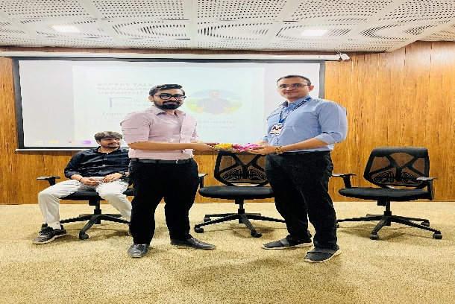
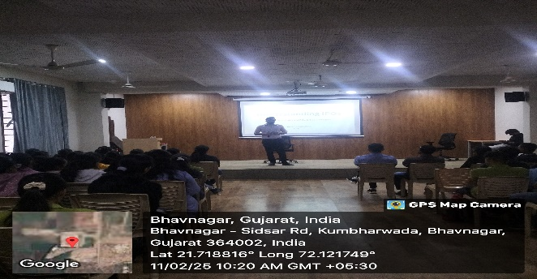

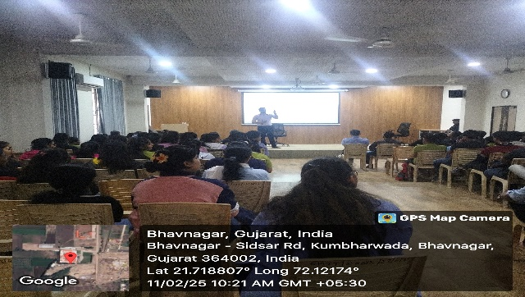
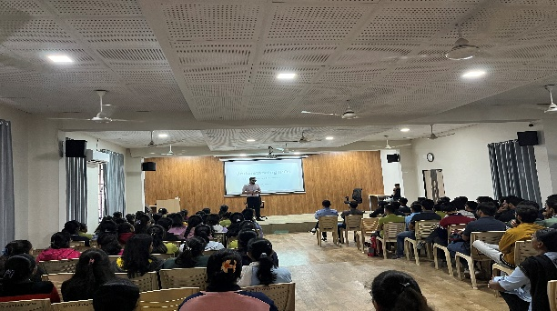

Department HOD Name | Dr. Mandeep Majmudar
Remarks:

Event/Activity feedbacks by faculty or students (if have any)

Note: Event/Activity forms must be submitted within 2 days with Canva post/Reel. (Soft copy-word)

